**Timeline for Dialogue**

**Objective:** We’re going to change our point system so that it only increases when destroying an enemy and also add a little dialog box with a character.

**Question:** What changes do you have to do in order to only give points when an enemy is destroyed?

1. Lets move the **scoreBoard.IncreaseScore** method call to the **killEnemy** method.
2. 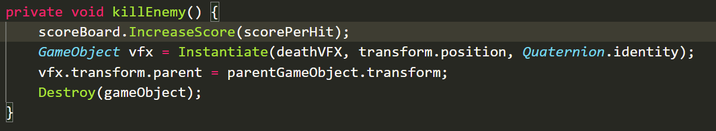
3. Click on Master Timeline and the Timeline tab
4. Click the **Plus** sign and then click on **Track Group**



1. Rename it to **Enemy Waves**
2. Move all the Control Track for the Enemy waves into this group

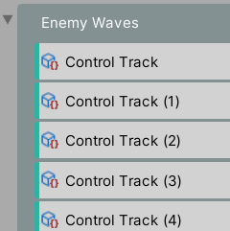

1. Add a 2nd Track Group and name it **Dialog**
2. Download the provided Zip File (Admiral Ackbar) or whatever Picture/sounds you have and add them to your Assets Folder
3. Open the Canvas prefab (by clicking on the arrow to the right of it in the hierarchy)
4. Click the 2D button
5. Right Click on **Canvas** and go to **UI > Image**
6. 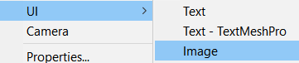
7. Anchor it to the Bottom Right
8. 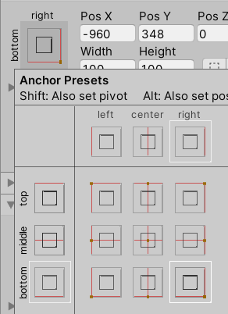
9. Move Image to bottom left
10. Click on the image you want to Import
11. In the Inspector change the **Texture Type** to **Sprite (2D and UI)**

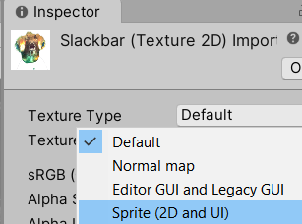

1. Click on the Image in the UI and change its Source Image to your chosen picture



1. Resize your Image by pressing T and grabbing the blue dot. Hold SHIFT to maintain Aspect Ratio
2. Move to bottom right
3. Rename **Image** GameObject to **Admiral**
4. Under **Amdiral Ackbar** add a **TextMesh Pro** as a child

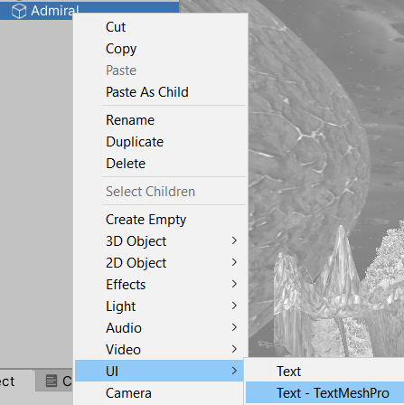

1. Replace New Text with Admiral
2. I changed the **Font Asset** to **Venus Rising**
3. I decreased **Font Size** to **28**
4. Moved the Text besides the image and change the size of the text box so it all fits

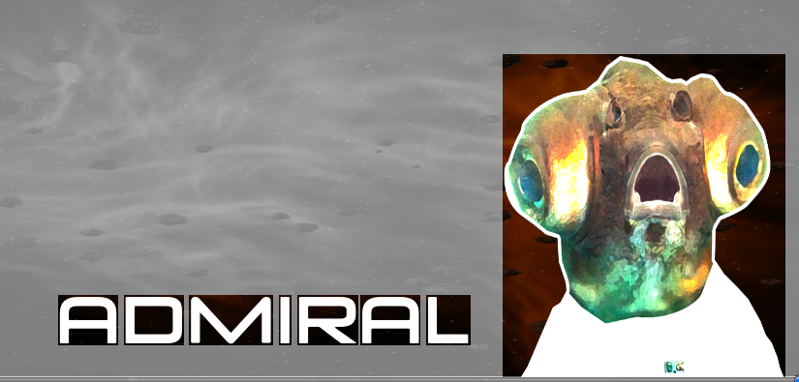

1. Leave the Prefab
2. Go to Master Timeline
3. Click on the Timeline tab and lock it in place
4. Drag the Admiral GameObject from the Canvas parent down to the Control track and it should add it

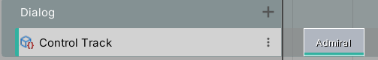

1. Press Play and test your game
2. Drag the Project tab next to the Hierarchy and lets just drag the audio clip you want into the Timeline under the 1st Dialog Control Track. Make sure it s apparent of the Dialog Control track
3. If you click on the Control Track in your timeline you get options in the Inspector. Adjust volume if needed.

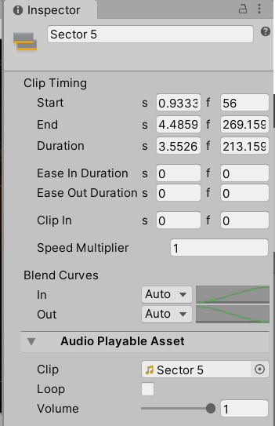

**Challenge:** Create various dialog points